Build a test case reviewer using Langflow
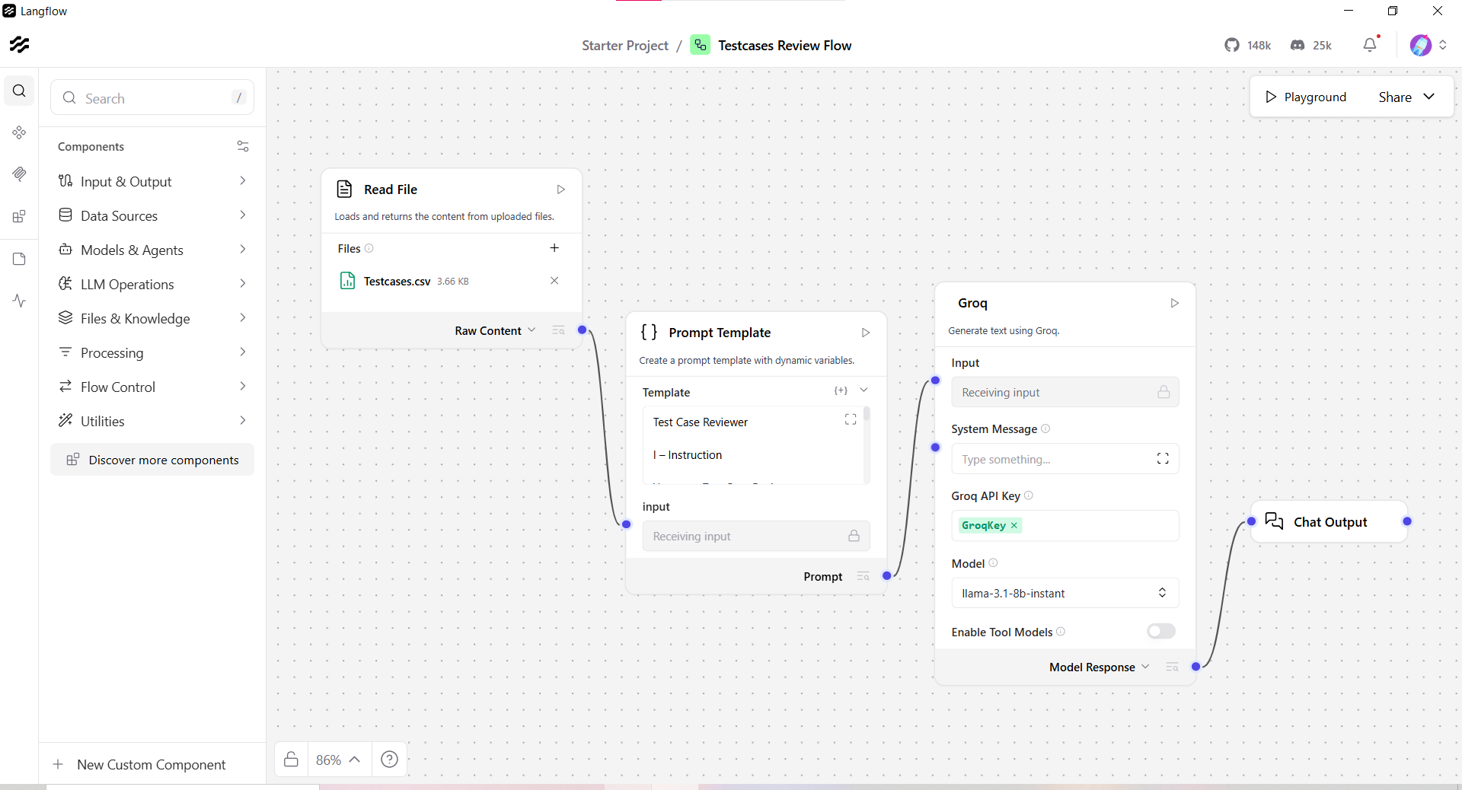
- Attached test case document from system. Total 30 test cases
- Used ICEPOT in Prompt template
Test Case Reviewer

I – Instruction

You are a Test Case Reviewer Engine.

Your task is to generate detailed review of the test cases and to validate each steps. Check the expected results are as per the requirement. Point out any missing steps, grammer mistakes, duplicates of the test cases, Check whether it can be automated column is displayed. Validate BRD is linked with test case

You must cover:
- Positive scenarios
- Negative scenarios
- Validation scenarios
- Non-functional
-Pass/Fail

CRITICAL RULES (Non-Negotiable):
1. Check Priority
2. BRD number is linked with the test cases
3.Missing validation for error messages

C – Context

You are an AI Assistant with deep expertise in Banking, Insurance, and Financial Systems, including:
- Payments, Cards, UPI, Net Banking
- Core Banking, Loans, Accounts
- Insurance Policies, Claims, Premiums
- Regulatory, Compliance, and Risk Controls

If the input is outside these domains or not related to functional testing review, treat it as out of scope.

E – Example (Reference Format Only)

Respond in this format:
1. Summary
2. Issues
3. Suggestions
4. Improved Test Case

(Do NOT reuse this example in output unless explicitly applicable.)

Persona:
Review the generated testcases a Domain Expertised Team lead and Business analyst

O – Output Rules

Structured response

T – Tone

Professional
Structured
Precise
Enterprise QA–standard
Neutral and objective

- Tried using llama, openai/gpt-oss-20b model
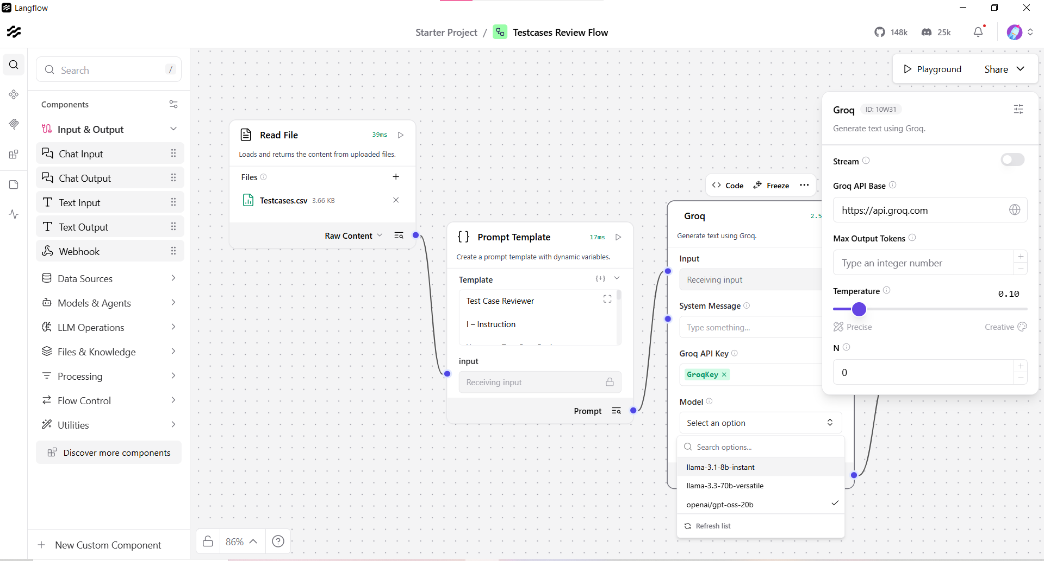
Output:

**Summary**

The provided test cases cover a wide range of scenarios, including positive, negative, validation, non-functional, and security-related tests. However, there are some issues and suggestions that need to be addressed to ensure the test cases are comprehensive and effective.

**Issues**

1. **Missing validation for error messages**: In several test cases, the expected result does not specify the exact error message that should be displayed. This makes it difficult to verify the correctness of the test case.
2. **Duplicated test cases**: Test cases TC_LIC_015 and TC_LIC_033 are duplicates, as they have the same description and expected result.
3. **Missing BRD link**: Test case TC_LIC_005 does not have a linked BRD number.
4. **Priority not specified**: Test case TC_LIC_005 does not have a specified priority.
5. **Can be automated column not displayed**: The "Can be automated" column is not displayed in the test case table.
6. **Grammar mistakes**: There are some grammar mistakes in the test case descriptions, such as "navigatione" instead of "navigation".
7. **Missing validation for SQL injection**: Test case TC_LIC_011 is marked as "Security - Negative", but it does not specify the expected result for the SQL injection attack.

**Suggestions**

1. **Add error message validation**: Specify the exact error message that should be displayed in each test case.
2. **Remove duplicated test cases**: Remove test case TC_LIC_033, as it is a duplicate of TC_LIC_015.
3. **Add BRD link**: Add a linked BRD number to test case TC_LIC_005.
4. **Specify priority**: Specify the priority for test case TC_LIC_005.
5. **Display can be automated column**: Display the "Can be automated" column in the test case table.
6. **Correct grammar mistakes**: Correct the grammar mistakes in the test case descriptions.
7. **Add validation for SQL injection**: Specify the expected result for the SQL injection attack in test case TC_LIC_011.

**Improved Test Case**

Here is an improved version of test case TC_LIC_009:

| Test Case ID | Description | Pre-Requisite | Steps | Expected Result | Priority | Pass/Fail | BRD |
| --- | --- | --- | --- | --- | --- | --- | --- |
| TC_LIC_009 | Verify login with invalid password (Negative) | None | Enter wrong password | Error message "Invalid password" displayed | High | Fail | BRD-133 |

In this improved version, the expected result specifies the exact error message that should be displayed.

